When you attempt to log in with a CAC not associated to your account, the system asks if you want this association. See below how to associate a CAC to an existing or new MarineNet account.

Associate CAC to Existing Account
1) Insert your CAC into the reader. Enter the MarineNet URL in your browser and press "Enter".

2) When the Warning Statement appears, click the "Agree" button.
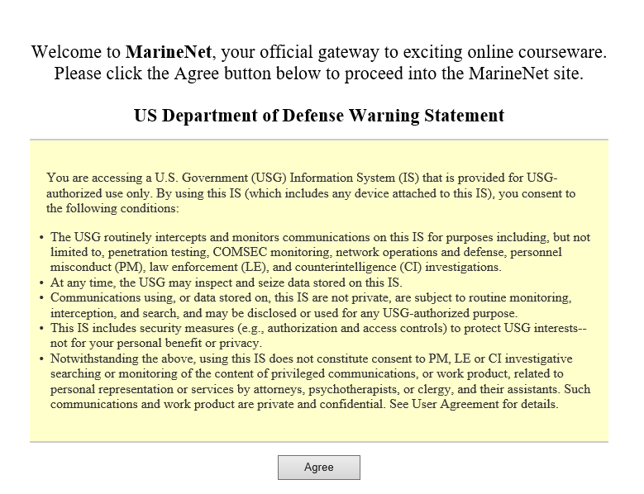
US Department of Defense (DoD) Warning Statement
3) When the Select a Certificate window displays, select a certificate and click "OK".
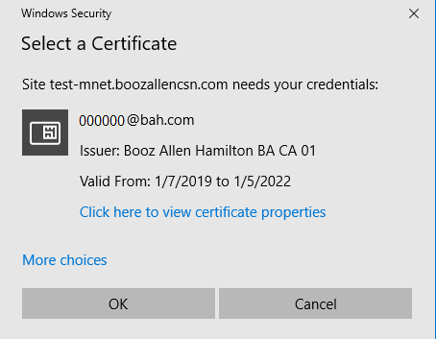
Select a Certificate Window

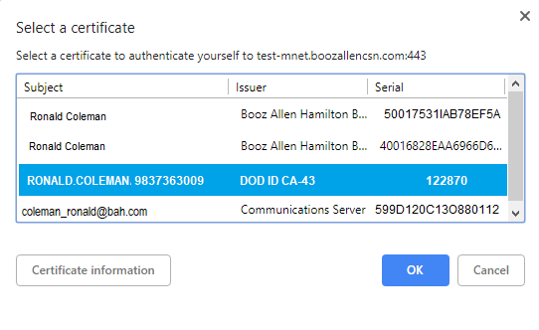
Select a Certificate Properties Window

4) Enter your PIN and click "OK".
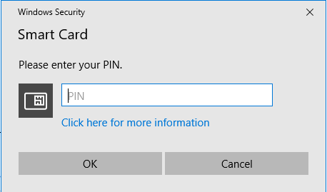
Enter Your PIN Window

5) When the Login Page opens, click the "Existing Account Start Here" button.
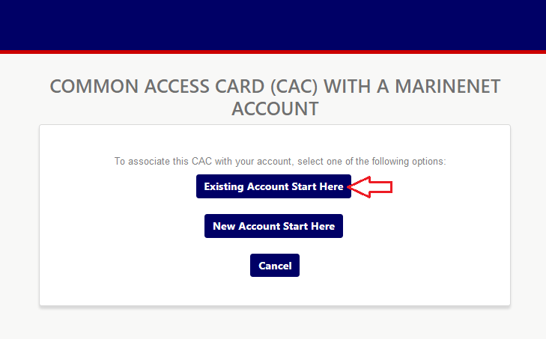
Associate CAC Buttons

6) Enter your Username and Password and click the "Log In" button.
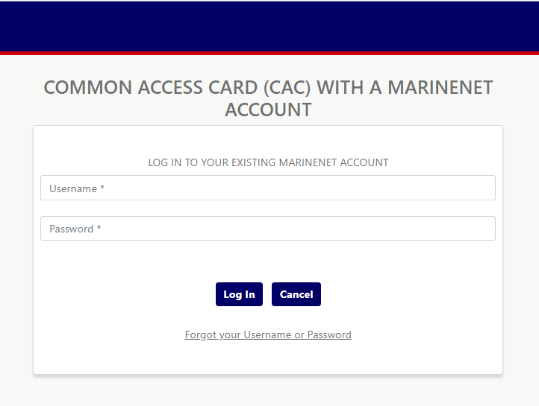
Associate CAC Login

7) The user's Profile Information displays, along with a success message for CAC association. Use this opportunity to review your Profile info. See Edit Your Profile for details about how to update your Profile information.
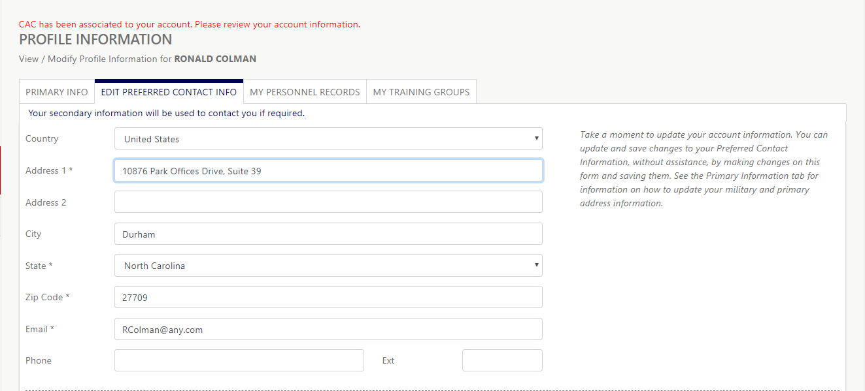
Profile / Edit Preferred Contact Info Tab

Associate CAC to New Account
1) Follow steps 1-4 above.

2) When the Login Page opens, click the "New Account Start Here" button.
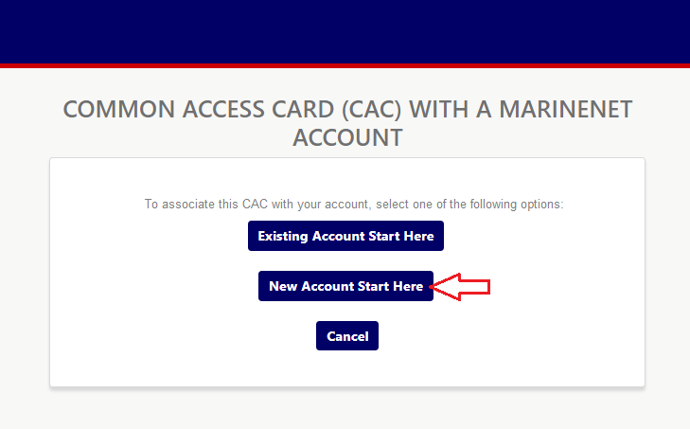
Associate CAC Buttons

3) See "Request or Create Account", above, beginning with Step 2, for the rest of this process.

