Create or Request MarineNet Account
1) Click the "Sign Up for a New MarineNet Account" link on the Login Page.
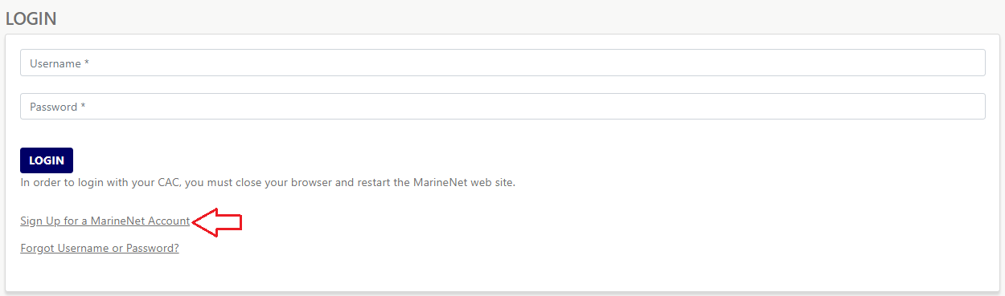
MarineNet Login with "Sign Up for a MarineNet Account" Link
2) When the Create Account form opens, enter your Social Security #, First Name, Middle Initial, Last Name, and Date of Birth. Place a check in the "Create account using CAC" box, if it applies. Click the "Next" button. The system will reach out to the authenticating sources to see if your info is found, in which case your account is created and logged in (see Step 2.a.). If your info is not found, you must complete the Account Request form (see Step 2.b.).
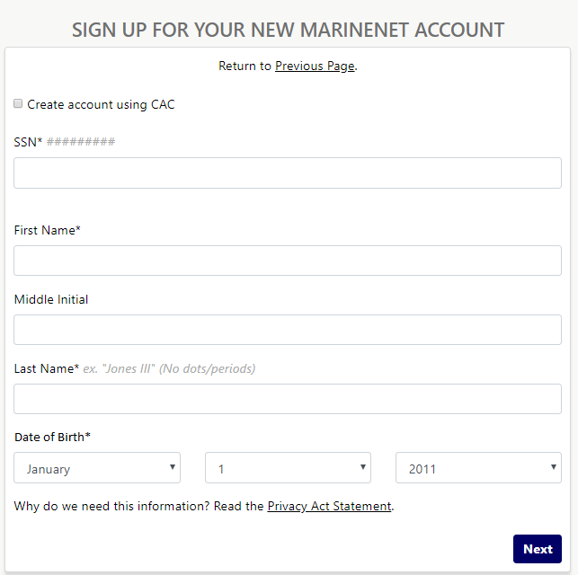
Create Account Form

2.a.) When you have been found in the authenticating systems, the Create Account form opens. Enter an account password and your email address on this form. Select a Security Question and then enter an answer for the selected question. Click the "Create User" button.
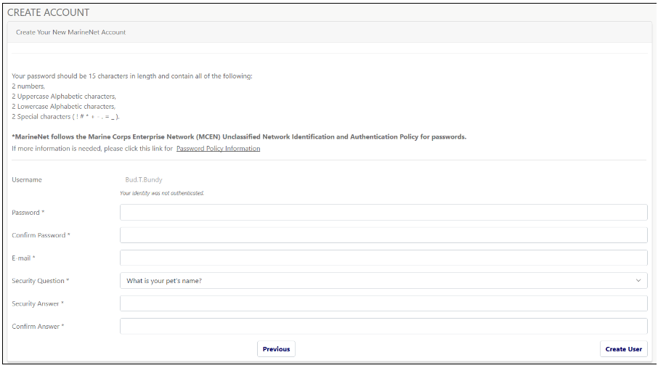
Create Your New MarineNet Account Page

2.b.) When the user was not found in the authenticating systems, the Account Request form opens. Add the requested information to the form fields. Note the fields that have an asterisk are required and their completion is mandatory.
Note: Sponsors will be required to meet criteria including having an existing MarineNet account and being a GS 12 or O-4 or above (Excluding National Guard).
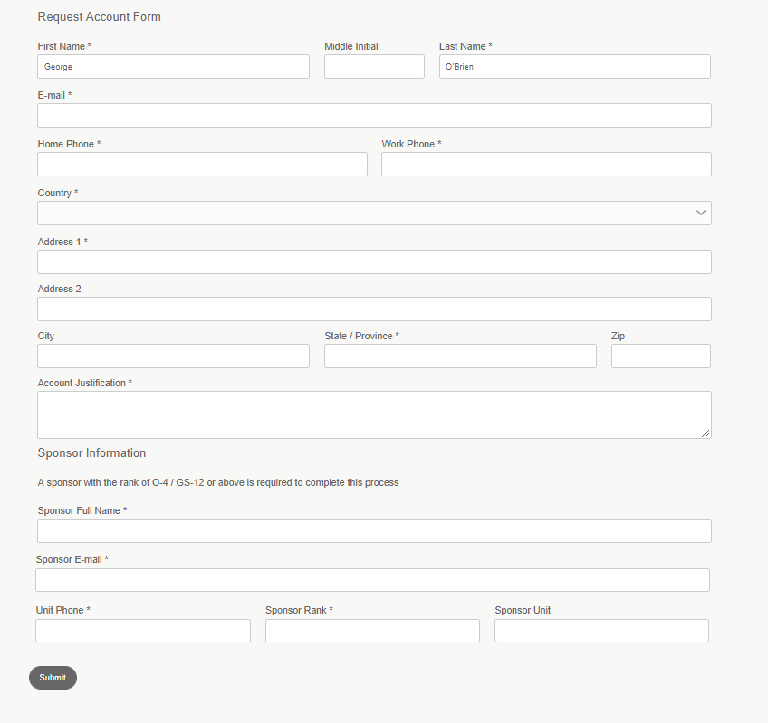
Account Request Form
Note: When the user selects a country other than the United States, the form's address fields change dynamically, based on country usage.

2.b.i.) After you complete the form and click the "Submit" button, a message stating that your request was successfully submitted displays. The message also contains further information about the request (see below). This same information will be sent to the email address provided on the form.
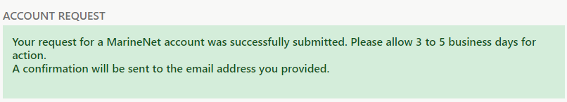
Success Message
2.b.ii.) It takes 3 to 5 days to process a new User Account Request. Once it has been processed, you will receive an email with your Student ID, username, and temporary password.
2.b.iii.) At first login, you must change your password and provide a Security Question/Answer. See the following: Provide a Security Q/A and Change your Password.

